Year 12 Chemistry Semester 2 Exam 2009 Solutions

Part 1

1 (b) 16 (c)
2 (c) 17 (b)
3 (c) 18 (a)
4 (a) 19 (c)
5 (d) 20 (d)
6 (a) 21 (d)
7 (c) 22 (b)
8 (c) 23 (a)
9 (b) 24 (b)
10 (d) 25 (a)
11 (b) 26 (d)
12 (a) 27 (b)
13 (c) 28 (d)
14 (a) 29 (c)
15 (c) 30 (c) [60]

Part 2

1. Equation: [1 mark for correct species, 1 mark for balanced equation]
Do not penalise for missing or incorrect state symbols
Maximum 1 mark if molecular/formula equation used

Observations: Need to give ‘bulk’ of answer for 1 mark
(at least two observations)

(a) 2PO₄³⁻ + 3Ca²⁺ → Ca₃(PO₄)₂ [2]

White precipitate forms [1]

(b) Cu + 2NO₃⁻ + 4H⁺ → Cu²⁺ + 2NO₂ + 2H₂O [2]

The solid dissolves to form a green/blue coloured solution. A brown pungent gas is evolved. [1]

(c) CH₃CH₂CH₂CH₂CH₂OH + CH₃COOH → CH₃COOCH₂CH₂CH₂CH₂CH₃ +H₂O [2]
A sweet smelling substance (liquid) is produced. [1]

(d) Zn(OH)₂ + 4NH₃ → 2Zn(NH₃)₄²⁺ + 2OH⁻ [2]

White solid dissolves to form colourless solution. [1]

[12 marks]

2.
Species | Electron dot structure
Perchlorite ion,  OCl⁻ | 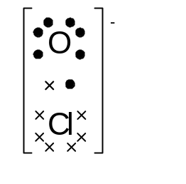  [2]
Hydrogen cyanide,  HCN | 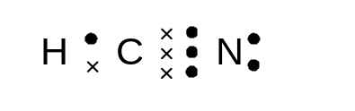  [2]
Lead (II) carbonate  PbCO₃ | C  O  O  O  2-  Pb ²⁺  [2]

[6 marks]
3. PbS + 4H₂O → PbSO₄ + 8H⁺ + 8e⁻ [1]
H₂O₂ +2H⁺ + 2e⁻ → 2H₂O [1]

PbS + 4H₂O₂ → PbSO₄ + 4H₂O (overall) [1]

[3 marks]

4.
Ion | Hydrolysis reaction | Acidic (A) or Basic (B) ion.
NH₄⁺ | NH₄+ + H₂O NH₃ + H₃O⁺ [1] | A [1]
CO₃²⁻ | CO₃²⁻ + H₂O HCO₃⁻ + OH⁻ [1] | B [1]

[4 marks]

5. (a) Li → Li⁺ + e⁻ and I₂ + 2e⁻ → 2I⁻

2Li + I₂ → 2Li⁺ + 2I⁻ [2]

(b) Water (oxidant) would react with the active metal Li (reductant). [1]

[3 marks]
6. Intramolecular and intermolecular/ possibly a diagram [1]
Intramolecular – strong, covalent bonding [1]
Intermolecular – strong, hydrogen bonds [1]
[3 marks]
7 (a) fractional distillation [1]

(b) many possible answers: extraction of metals, fertiliser production, explosives manufacture, cheap base [1]

(c) Reactant molecules collide with the surface of the catalyst and may become attached to the metal surface [1]
Molecular rearrangements that subsequently occur [bonds break and individual atoms then associate] require less energy [1]

(d) As temperature increase the rate of collisions increase [1]
With a catalyst less collision energy is required. [1]
With more collisions occurring (higher pressure and temperature) a great proportion of molecules will have sufficient activation energy and be able to form ammonia [1]

(e) Under pressure the ammonia liquefies and is drawn off; the gases N₂ and H₂ are recycled back into the reaction vessel. [2]

[9 marks]

8. (a)
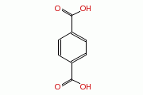[1] | 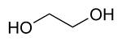  [1]

(b) Condensation polymerisation [1]

(c) No cross linking and weak intermolecular bonding [1]

[4 marks]

9.
Change made to the equilibrium system | Effect on rate of the forward reaction | Effect on the equilibrium yield of Ni(s)
NH₃(g) is removed | DECREASE | INCREASE
Temperature is decreased | DECREASE | INCREASE
An appropriate catalyst is added | INCREASE | UNCHANGED
[6 marks]

10. (a) The copper pipe acts as a cathode [1]
At the point of contact of the copper and iron pipe the iron (anode) will corrode
i.e. the attachment of the two different metals facilitates the corrosion of the more active metal (Fe) [1]

(b) The aluminium is the sacrificial anode [1]
The aluminium corrodes in preference to the Fe superstructure [1]

[4 marks]

11. (a) cryolite lowers the melting point of the alumina [1]

(b) The fossil fuel used to produce the large amounts of electricity required is coal [1]

(c) CO₂ [1] and CF₄ [1]

[4 marks]
12. (a)
Name | Structural (or semi structural) formula
3-bromo-2,3-dimethyl-1-pentanal | 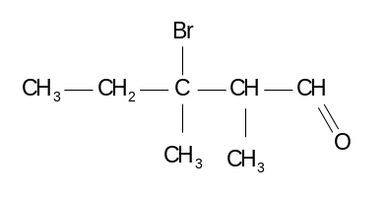[2]
cis-1,2-dichloropropene | 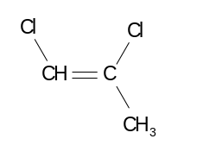 [2]
(b) 2-methyl-2-butanol [1]
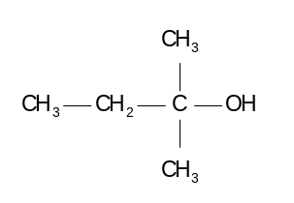[1]

(c) H₂ [1]
sodium 2-methylbutanoxide [1]

[8 marks]

13. (a) The system has reached equilibrium [1]

(b) Reactant has been added [1]

(c) [(NH₄)₂S] increased gradually [1]
[NH₃] decreased gradually but steeper than (NH₄)₂S [1]
[H₂] decreased gradually [1]

(d) A catalyst would make the changes faster and equilibrium would be reached before 2.0 sec [1]

[6 marks]

Part 3
C
H
H
H

1. (a) (NH₄)₂SO₃ (s) → NH₃(g) + SO₂(g) + 2H₂O(g) [1]

(b) n((NH₄)₂SO₃) = 1.54 / 116.154 = 0.01326 mol [1]

n(gas)_{total} = n(NH₃) + n(SO₂) + n(H₂O) [1]

n(gas) = (0.01326)+( 0.01326)+(2 x 0.01326) = 0.05303 mol [1]

P(gas) = nRT / V

= 0.05303 x 8.315 x (302+273) / 1.85 = 137 kPa [1]

(c) n(SO₂) = n((NH₄)₂SO₃) = n(CaSO₃) = 0.01326 mol [1]

m(CaSO₃) = 0.01326 x 120.15 = 1.59 g [1]

[7 marks]

2. (a) Ca₃(PO₄)₂(s) + 2H₂SO₄(aq) → Ca(H₂PO₄)₂(s) + 2CaSO₄(s) [1]

(b) m(Ca₃(PO₄)₂)_{pure} = 0.75 x 35 000 = 26 250 kg [1]

n(Ca₃(PO₄)₂)_{pure} = 26 250 x 1000 / 310.18 = 84 628 mol [1]

n(H₂SO₄) = 18.0 x 15 000 = 270 000 mol [1]

n(Ca₃(PO₄)₂(s)) _{required} = ½ x n(H₂SO₄(aq))_{required} [1]

Stoichiometric ratio is: 1:2 and actually ratio is approx. 1:3.2
Therefore LR is Ca₃(PO₄)₂ [1]

(c) n(H₂SO₄)_{excess} = 270 000 – 2(84 628) = 100 743 mol [1]

m(H₂SO₄)_{excess} = 100 743 x 98.076 = 9.88 x 10⁶ g [1]
(9.88 tonnes)

(d) n(Ca(H₂PO₄)₂(s))_{produced} = n(Ca₃(PO₄)₂(s)) _{reacted} [1]

n(Ca(H₂PO₄)₂(s))_{produced} (if 80.0% efficient) = 0.80 x 84 628

= 67 702.6 mol [1]

m(Ca(H₂PO₄)₂(s))_{produced} (if 80.0% efficient) = 67 702.6 x 234.052 g

= 15.8 tonnes [1]

(e) To make bone, teeth, ATP, DNA, phospholipids (one of) [1]

[12 marks]

3. (a) m(C)_{in 3.22 g} = 12.01 / 44.01 x 5.51 g = 1.504 g

%(C) = 1.504 / 3.22 g x 100% = 46.70% [1]

m(H)_{in 3.22 g} = 2 x 1.008 / 18.016 x 1.28 g = 0.1432 g

%(H) = 0.1432 / 3.22 x 100% = 4.45% [1]

n(NO₂) = PV / RT = 103 x 1.12 / (8.315 x 373)

= 0.03719 mol [1]

m(N)_{in 1.68 g} = 0.03719 x 14.01 = 0.5211 g

%(N) = 0.5211 / 1.68 x 100% = 31.02% [1]

%(O) = 100 – (46.70 + 4.45 + 31.02) = 17.83% [1]

C H N O

n 46.70 / 12.01 4.45 / 1.008 31.02 / 14.01 17.83 / 16.00

n 3.888 4.419 2.214 1.114 [1]

n 3.888 / 1.114 4.419 / 1.114 2.214 / 1.114 1.114 / 1.114 [1]

n 3.49 3.97 1.99 1.00

Therefore EF (theobromine) = C₇H₈N₄O₂ [1]

(b) M(EF) = 7 x 12.01 + 8 x 1.008 + 4 x 14.01 + 2 x 16.00

= 180.174 [1]

Therefore the EF = MF i.e. MF (theobromine) = C₇H₈N₄O₂ [1]

(c) Toxicity level (for 8.00 kg dog) = 8.00 x 300 mg

= 2400 mg

= 2.40 g theobromine [1]

Mass of brand chocolate = 2.40 x (100 / 2.50)

= 96.0 g [1]

[12 marks]

4. (a) [H+] = 10 ^{-1.80} M = 0.158 M [1]

(b) Mg(OH)₂ + 2H⁺ → Mg²⁺ + 2H₂O [1]

Al(OH)₃ + 3H⁺ → Al³⁺ + 3H₂O [1]

(c) n(Mg(OH)₂) _{in 10.00 mL} = 0.350 / 58.316

= 6.002 x 10⁻³ mol [1]

n(Al(OH)₃) _{in 10.00 mL} = 0.300 / 78.004

= 3.846 x 10⁻³ mol [1]

n(OH⁻) _{total} = (2 x 6.002 x 10⁻³) + (3 x 3.846 x 10⁻³)

= 0.02354 mol [1]

n(HCl) _{required} = 0.02354 mol [1]

v(HCl)_{required} = 0.2354 / 0.158 = 0.149 L

= 149 mL [1]

(d) stomach bloating or gas, due to the evolution of CO₂ gas [1]

[9 marks]

5. (a) Q = It = 0.500 x 250 x 60 = 7500 C [1]

n(e⁻) = 7500 / 96 490 = 7.773 x 10⁻³ mol [1]

n(Cu) = ½ x n(e⁻) = ½ x 7.773 x 10⁻³ mol

= 0.03886 mol [1]

m(Cu) = 0.03886 x 63.55 = 2.47 g [1]

(b) mass loss at anode = 2.47 g [1]

(c) [CuSO₄]_{final} = 1.50 M [1]

(d) Cr₂O₇²⁻ + 14H⁺ +12e⁻ → 2Cr + 7H₂O [1]

(e) n(Cr) = 5.45 / 52.00 = 0.1048 mol [1]

n(e⁻) _{required} = 6 x 0.1048 = 0.6288 mol [1]

Q = 0.688 x 96 490 = 60 677 C [1]

t (taken to Cr plate) = 60 677 / 2.04 = 29 743 s

= 8.26 hrs [1]

(f) n(CrO₃) _{required} = n(Cr) _{used} = 0.1048 mol [1]

m(CrO₃) _{required} = 0.1048 x (52.00 + 48.00)

= 1.05 g [1]

[13 marks]

Part 4 (20 Marks) Model Answer
It is not expected that students need to cover all points in order to obtain maximum marks. Credit should be given for accurate use of equations, diagrams and examples. No credit is given for directly repeating information given in the question, nor for areas of chemistry not mentioned in the question.

Chemical equations / reactions
Mostly redox reactions:
(i) Mn²⁺ + 2OH ⁻ → Mn(OH)₂
(ii) 4Mn(OH)₂ + O₂ + 2H₂O → 4Mn(OH)₃
(iii) Mn(OH)₃ + 3H+ → Mn³⁺ + 3H₂O
(iv) (Mn³⁺ + e⁻ → Mn²⁺) x 2
2I⁻ → I₂ + 2e⁻
(v) I₂ + starch → “I₂- starch complex” (blue)
(vi) 2S₂O₃²⁻ + I₂ → S₄O₆²⁻ + 2I⁻
Stoichiometry
n(dissolved oxygen, O₂) can be mathematically linked to the amount of iodine formed.

Procedure
1. At the lake, put on safety gloves (water may be polluted).
2. Measure and record the temperature of the lake water (temperature affects oxygen solubility).
3. Collect 4 x 300 mL samples of water, full to brim in tightly sealed bottles. Place bottles under water so that no oxygen is lost or added. Label bottles.
4. In the laboratory, unscrew lid of bottles and add reagents (MnSO₄ and NaOH) using a graduated pipette. Place the pipette into the solution to avoid adding O₂ from air on solution surface.
Safety gloves should be worn as some reagents are toxic/irritating to the skin.
5. Reseal bottle and invert to mix reagents. A brown solid will settle.
Added acid will react with the metal hydroxide Mn(OH)₃ to dissolve it. All dissolved O₂ should now be “fixed”.
6. Both NaI and MnSO₄ solutions would have been prepared by weighing out a given mass of solid (top loading balance) and placing in a volumetric flask. Distilled water is added to take the volume up to the mark (graduation).
7. Using a pipette take 20.00 mL aliquots of the solution and place in conical flasks ready for titration.
8. Flush out a burette with distilled water and then with a small volume of standardised sodium thiosulfate solution. Set up all glassware and retort stand/burette holder.
9. Add starch indicator to each flask and the solution will be blue coloured.
10. Titrate each flask, with swirling, until the first drop of excess sodium thiosulfate results in the solution turning colourless (endpoint). Repeat the procedure until concordant results are achieved.
11. Repeat steps 4 to 10 with the other water samples (bottles)
12. Analyse data and perform calculations to determine the amount of dissolved oxygen in each water sample. Account for any differences.

Diagram / flow chart
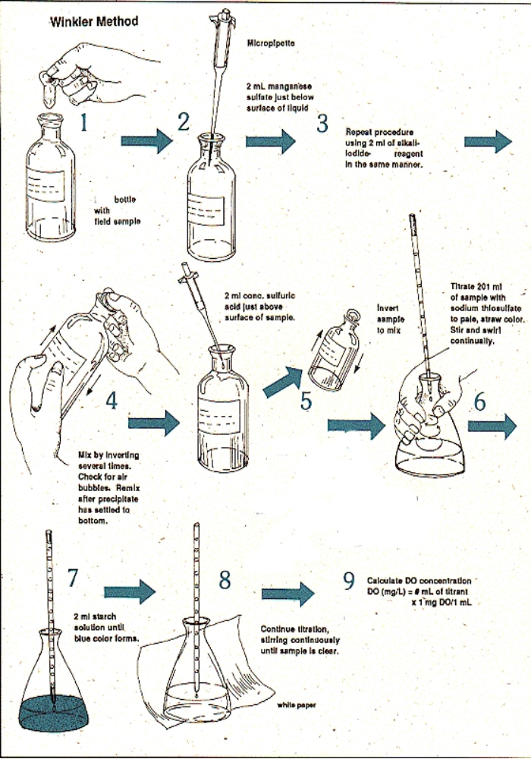

Possible errors / limitations

1. Difficulty in not adding or removing dissolved oxygen to/from the samples. Care in handling required. Any bottles with air bubbles in should be discarded.

2. Solutes in the water samples could react with iodine. Give a higher determination of dissolved oxygen. The water samples could be filtered (under water) before being added to sealed bottles.

3. Some sample volume is lost in adding reagents to the full bottles. Small volumes involved only 6 ml compared to 300 mL.

4. Difficult to control water temperature. Any comparisons of dissolved oxygen would need to be made at the same water temperatures.

